# Lab 5 Notes

Edward Venator and Chris Dickey

## 1.1

a) x1 resistance = negligible (<.1Ω)  
x100 resistance = 3.61Ω

b)

|  |  |
| --- | --- |
| X1 | X100 |
| |  |  |  | | --- | --- | --- | | **Resistance** | **Max VPP** | **Peak Current** | | Infinite | 16.9 | 0 | | 100000 | 16.9 | 0.0000845 | | 10000 | 16.9 | 0.000845 | | 1000 | 16.4 | 0.0082 | | 268 | 12.1 | 0.022574627 | | 195 | 10.2 | 0.026153846 | | 111 | 6.9 | 0.031081081 | | 29 | 2.3 | 0.039655172 | | 1 | 0.16 | 0.08 | | |  |  |  | | --- | --- | --- | | **Resistance** | **Max VPP** | **Peak Current** | | Infinite | 16.1 | 0 | | 100000 | 16.1 | 0.0000805 | | 10000 | 16.1 | 0.000805 | | 1000 | 15.6 | 0.0078 | | 262 | 12.2 | 0.0232824 | | 185 | 10 | 0.027027 | | 122 | 7.3 | 0.029918 | | 28 | 2.2 | 0.0392857 | | 1 | 0.14 | 0.07 | |

Output saturation voltage is about .5V closer to the top rail than the bottom rail w/ no loading.

c) Extremely small small-signal output resistance does not take into account current limiting, which become significant for large voltage across small-resistance loads.

d) See 1 Ohm above (~75mA)

## 1.2

a)

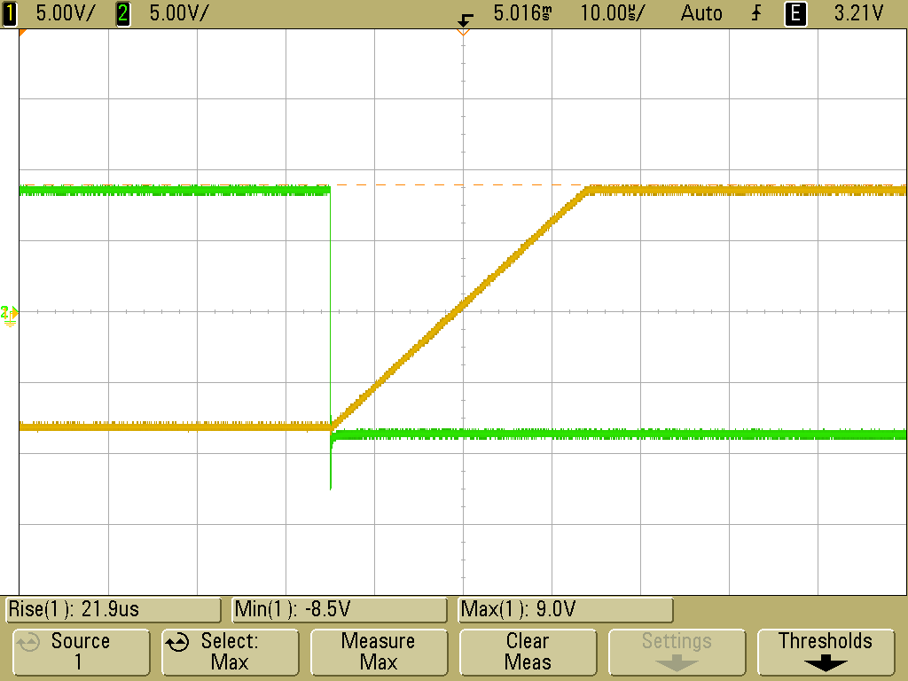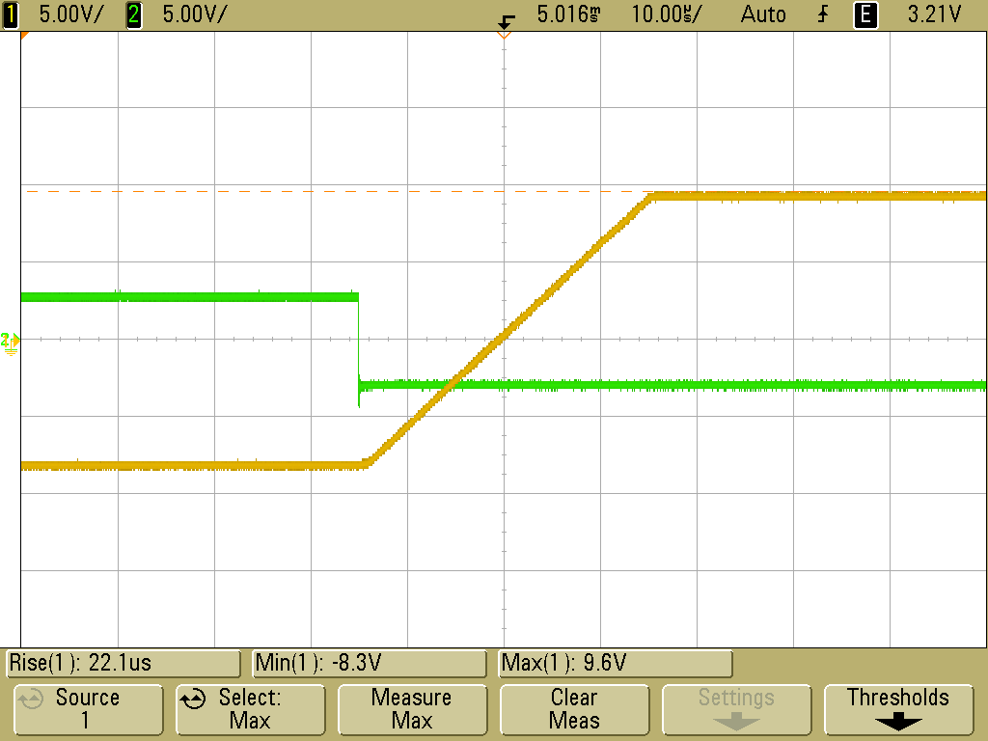

x1 Slew Rate (left) = 0.80 V /usec

x100 Slew Rate (right) = 0.81 V/usec

Closed loop gain has a minimal effect on slew rate, but higher gains appear to have faster slew rate (this is not intuitive).

b)

Notes:

* Slew rate distortion at 20kHz
* Distorted to triangle wave at 30kHz
* -3dB point at ~43kHz

Notes:

* -3dB (37dB) point at ~5kHz
* Spikes appear at zero-crossing points at 200kHz

c) The third factor that limits Vp-p of an op-amp are the Base-emitter voltage drops on the output transistors, but we chose input values that avoided the rails for our testing, so we did not observe the effects of this.

## 2.1

CMRR = 59.6dB

CMRR could be less than spec’d because the two input resistors are not equal, which might cause a higher gain on the non-inverting input than the inverting input.

## 2.2

## 2.3

## 2.4

PNP output transistors allow this amp’s output to drop all the way to the lower rails.

## 2.5

60hz buzz completely swamped the 1kHz power supply variation.

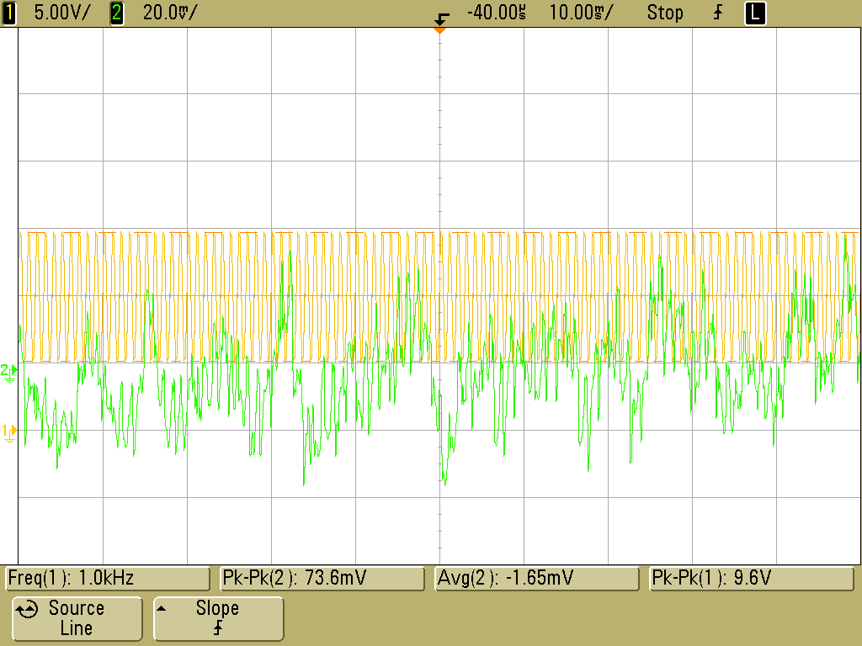 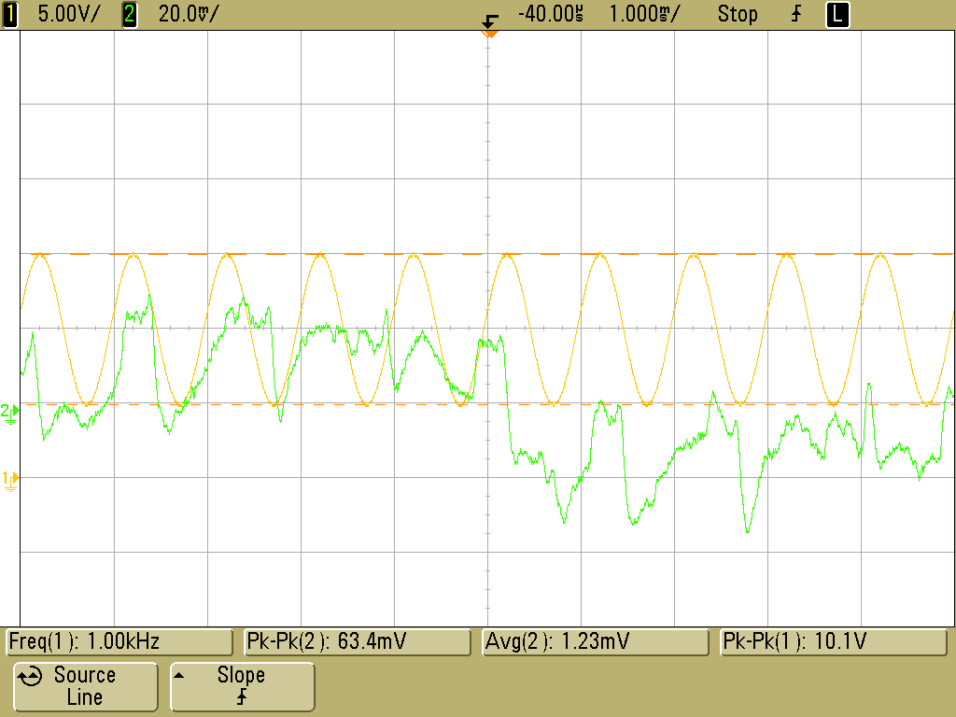

Channel 1 is Power supply (10 Vpp swing centered at 10V). Channel 2 is output of amplifier (.01V x100). Although some power supply coupling is detectable, the line noise is far worse.

## 3.1

W/ 34k pullup resistance, rise time is 2.25us. At the max input frequency available from the function generator (100kHz), this does not affect the output amplitude, but the wave is no longer properly square.

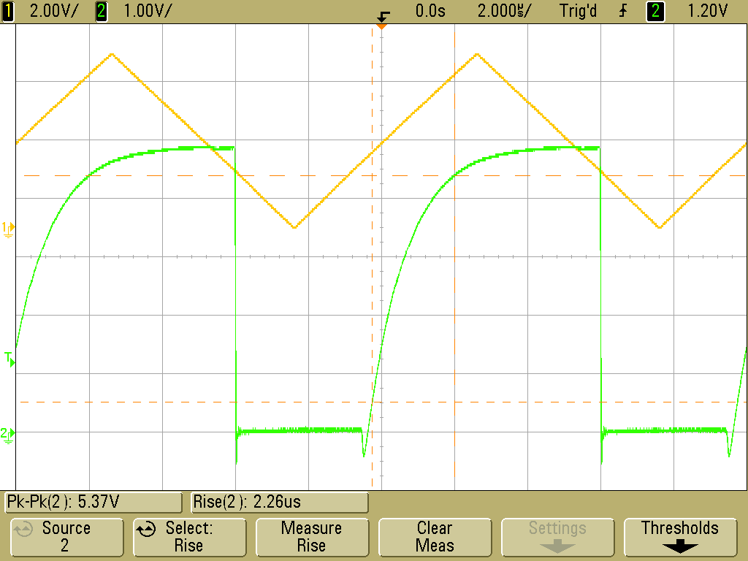

W/ 1.1k pullup resistance, rise time is 70ns. At the max input frequency (100kHz), the output waveform is still square.

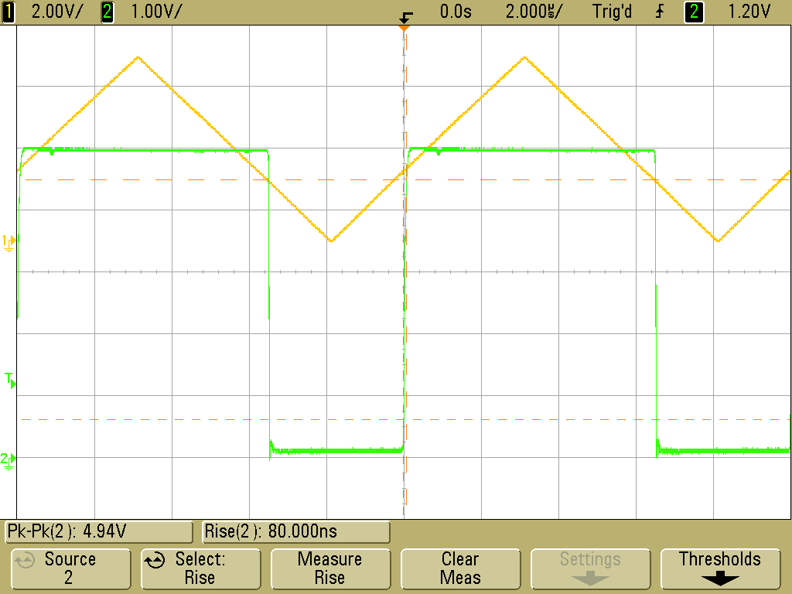

## 3.2

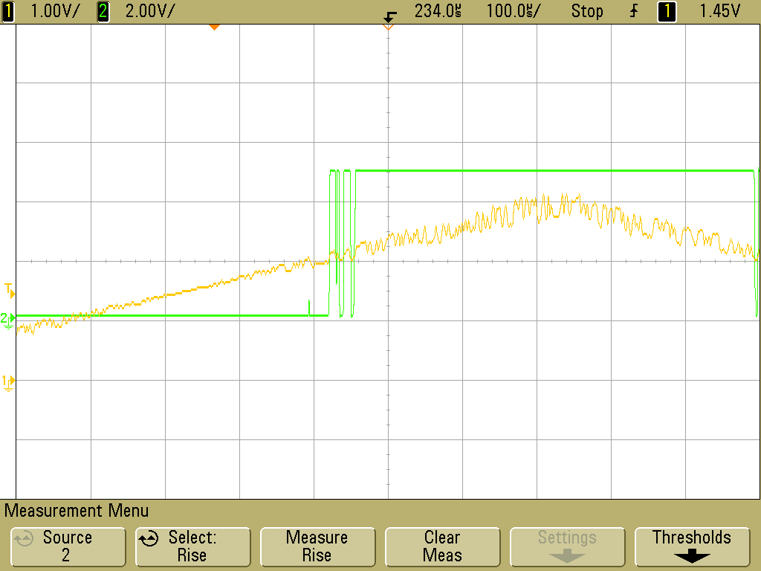

## 3.3

